1. Why Security Is a First-Class Concern in Spring Boot Applications

Any backend application exposes resources such as APIs, data, and business logic. Without security, anyone can access or manipulate these resources. In real systems, security is not an add-on; it is part of the core architecture.

Spring Boot Security, provided mainly through Spring Security, addresses three fundamental questions:

- Who is the user? (Authentication)
- What is the user allowed to do? (Authorization)
- How are credentials protected? (Credential management and encryption)

2. Spring Boot Security: What It Is and How It Fits

Spring Boot Security is a framework that integrates Spring Security into Spring Boot applications with minimal configuration. At an architectural level, it acts as a security layer that intercepts every incoming request before it reaches controllers or services.

Core Architectural Idea

- Every HTTP request passes through a security filter chain.
- The filter chain verifies identity, validates credentials, and enforces access rules.
- Only authorized requests are allowed to reach business logic.
- This ensures security is centralized, consistent, and independent of business code.

2.1 Security Filters and SecurityFilterChain

SecurityFilterChain is the gatekeeper of your application.
Every HTTP request must pass through it before reaching any controller or service.

In practice, it does three things:

- Decides who the user is (authentication)
- Decides what the user can access (authorization)
- Blocks unsafe or malicious requests automatically

It runs before business logic, so insecure requests never touch your code.

What Happens When You USE SecurityFilterChain

- Requests are intercepted and validated
- Users must authenticate before accessing protected APIs
- Roles and authorities are enforced consistently
- Passwords are validated using secure encoders (e.g., BCrypt)
- CSRF, session control, and other protections work automatically

Result:
Only valid, authorized users reach controllers. Security is centralized and reliable.

What Happens If You DO NOT Use SecurityFilterChain

- Requests go directly to controllers
- No automatic authentication or authorization
- Anyone can access APIs unless you manually check everywhere
- Password and session protection must be written by hand
- High risk of security bugs and data exposure

Result:
Security becomes scattered, error-prone, and easy to bypass.

How the SecurityFilterChain Works (Request Flow)

The request processing flow can be summarized as follows:

- A client sends an HTTP request to the application
- The request enters the Spring Security filter chain
- Authentication filters verify user identity if required
- Authorization filters check user roles or authorities
- Additional filters handle concerns such as CSRF and session management
- If all checks pass, the request is forwarded to the controller
- If any check fails, the request is rejected before reaching business logic

This design ensures that all security enforcement happens before application logic is executed.

Why Filters Are Architecturally Important
Using a filter-based security model provides several advantages:
- Security rules are applied uniformly to all requests
- Business logic remains clean and free from security concerns
- Security behavior can be modified without changing application code
- Multiple authentication mechanisms can coexist within the same system

The SecurityFilterChain therefore acts as a protective boundary between external clients and internal application components.
3. User Management: Why Users Must Be Stored in the Database
Why Not Hardcoded Users?

Hardcoding users in configuration files or code is acceptable only for demos. In real systems:
- Users change passwords
- Users are added or removed
- Roles evolve over time
- Audit and compliance are required
- All of this demands persistent storage.
- User in the Database: Architectural Role
- The database becomes the system of record for identity information.

Typical user-related data includes:

- Unique identifier (user ID)
- Username or email
- Encrypted password
- Roles or authorities
- Account status (active, locked, expired)

Spring Security accesses this data through a UserDetailsService, which acts as an abstraction layer between security logic and the database.

This design:

- Decouples security from persistence technology
- Allows switching databases without rewriting security logic
- Supports scalability and maintainability

4. Password Handling: Why Plain Text Is Never Acceptable

Storing passwords in plain text is one of the most critical security failures.

Why Plain Passwords Are Dangerous

- If the database is leaked, all user accounts are immediately compromised
- Users often reuse passwords across systems
- Regulatory standards explicitly forbid plain password storage
- Passwords must be treated as secrets that the system itself should never be able to read.

5. Password Encoding: The Role of BCrypt
What Password Encoding Really Means

Password encoding is not encryption. Encryption is reversible; encoding (hashing) is intentionally one-way.

BCrypt is a cryptographic hashing algorithm designed specifically for passwords.

Why BCrypt Is Preferred

BCrypt provides several critical properties:

- One-way hashing: The original password cannot be reconstructed
- Salted hashes: Each password has a unique salt, preventing rainbow table attacks
- Adaptive cost factor: The hashing complexity can increase over time as hardware becomes faster

From a security architecture view, BCrypt shifts the problem from “protect the database” to “make stolen data useless.”

6. Authentication Flow with Database Users and BCrypt

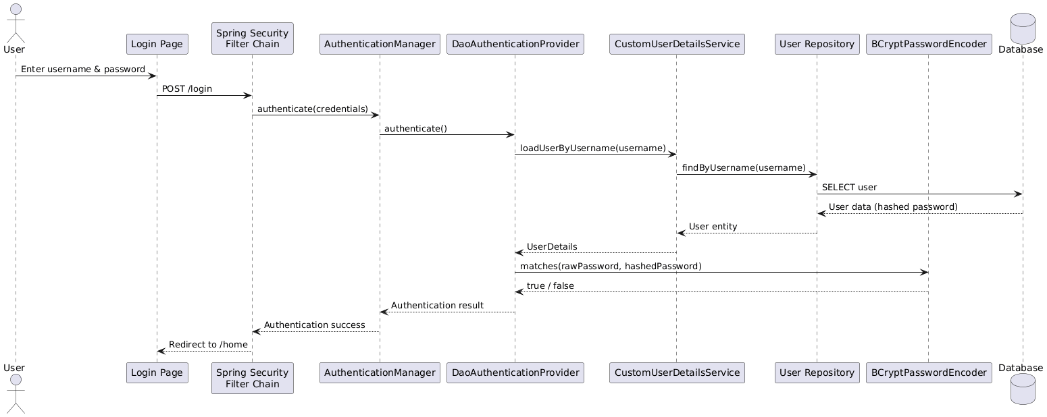
Let’s walk through the process end to end.

Step 1: User Registration

- User submits a password
- The application applies BCrypt encoding
- Only the hashed value is stored in the database
- The plain password is immediately discarded
- At no point is the raw password persisted.

Step 2: User Login

- User submits username and password
- Spring Security retrieves the stored hashed password from the database
- BCrypt hashes the incoming password using the same algorithm
- The hashes are compared
- If they match, authentication succeeds
- The system never compares plain text passwords.

7. How Spring Security Enforces This Architecture

Spring Security enforces best practices by design:

- Authentication is handled by an AuthenticationManager
- Password verification is delegated to a PasswordEncoder
- User data is loaded through UserDetailsService

This layered approach ensures:
- Clear separation of concerns
- Minimal risk of accidental insecure implementations
- Centralized security control

8. Architectural Benefits of This Approach

Using Spring Boot Security with database-backed users and BCrypt provides:

- Confidentiality: Passwords are never exposed
- Integrity: Authentication logic cannot be bypassed easily
- Scalability: Supports thousands or millions of users
- Compliance: Aligns with industry security standards
- Maintainability: Security rules evolve independently of business logic

9. Summary

- Spring Boot Security provides a centralized security mechanism for applications
- Users must be stored in a database to support real-world identity management
- Passwords must never be stored or transmitted in plain text
- BCrypt ensures secure, one-way password hashing with built-in protection against modern attacks

